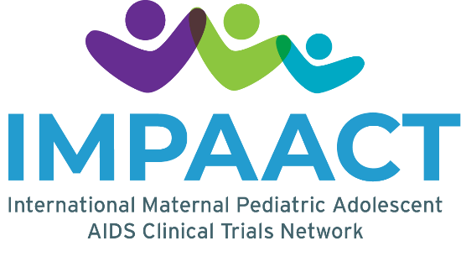
IMPAACT Early Career Investigators
Request for Proposals

Background/Goal: The International Maternal Pediatric Adolescent AIDS Clinical Trials (IMPAACT) Network conducts high quality clinical trials to advance the prevention and treatment of HIV and its complications for infants, children, adolescents, and pregnant/postpartum people globally. This request for proposals is to encourage early career investigators (ECIs) to propose a project that takes advantage of data and/or biological specimens generated by the IMPAACT Network.

Approved applicants will be expected to present findings at an IMPAACT Annual Meeting and at one or more other scientific meetings. They will also be expected to submit a manuscript to a peer-reviewed journal ideally within the two-year funded project.

Investigators are invited to submit a proposal by the deadline of 1 October 2024, for project funding expected to begin in December 2024.

Eligibility:
Interested applicants must meet the following eligibility criteria:
      - Affiliated with the IMPAACT Network.
      - Holds a current master’s degree, doctoral degree, or MD (or local equivalent) and is within 10 years of graduation of their final degree or fellowship/training.
      - Has experience either developing or participating in clinical research.
      - Has support of employer or work institution.
      - Proposed project uses data and/or specimens from one or more of the concluded IMPAACT studies listed on the IMPAACT website (https://www.impaactnetwork.org/studies). Projects proposing use of data and/or specimens from a study not yet concluded, must include a letter of support from the applicable study’s Protocol Chair. Projects proposing use of specimens obtained from non-IMPAACT studies will not be funded.
      - Proposed project can reasonably be completed within the 2-year period.

Mentors:
Applicants must identify a mentor who has been an investigator on an IMPAACT study and is ideally a current member of an IMPAACT Scientific Committee. Applicants are also encouraged to identify a second mentor from their region and/or institution.

Mentors must be willing to:
      - Meet regularly with the early career investigator
      - Provide timely assessment and feedback on the proposed project
      - Assist with establishing realistic timelines for the project
      - Provide support during data analysis and manuscript development
      - Facilitate networking that will benefit the investigator’s project and career

If further information is needed or if the applicant has difficulty locating a mentor, the applicant may contact Program Leadership at impaact.earlycareer@fstrf.org.

Parameters:
- This program will only support investigations using existing data and/or stored specimens from completed IMPAACT clinical trials. Requests for use of data and/or specimens from a study not yet “concluded” must include a brief statement of support from the protocol chair(s).
  - If the proposed analysis is currently underway or planned by other protocol team members, that analysis would not be considered eligible for support through this award. For this reason, interested investigators are strongly encouraged to contact the protocol chair before preparing a proposal.
- This program is not intended to (1) develop a new clinical trial, (2) use data and specimens from ongoing studies, or (3) collect prospective data.
- If biological specimens are to be used in the project, use of the IMPAACT/ACTG Specimen Repository website for identification of available specimens is required (http://www.specimenrepository.org). If additional assistance is needed beyond the search tools available on the website, the ‘contact us’ link on the website should be used and details on specimen availability should be further explained in the application.
- The proposed work must be completed and ideally submitted for publication within two years. Consideration of specimen location (if applicable) and time required to obtaining approvals for data use and shipping (e.g., Data Use Agreements, Materials Transfer Agreements), especially internationally, should be discussed in the proposal. Interested investigators are strongly encouraged to contact impaact.earlycareer@fstrf.org to identify any IRB restrictions and/or MTA requirements from sites that collected the samples early in the proposal writing process.
- IMPAACT Statistical and Data Management Center statistical support may be requested.
- Funding: A maximum total dollar amount of $100,000 (inclusive of 8% Indirect Cost) is available for each award over a two-year period, which may include level of effort support for the investigator. The typical level of support for the investigator is approximately 20-30%; however, some variation is allowed depending on the needs of the project. If support beyond this range is requested, include the justification in the budget justification memo. An additional $27,000 (inclusive of 8% Indirect Cost) is allowed to support laboratory assays, materials, and shipping of specimens to the laboratory of interest, if applicable. Therefore, the maximum award amount for the 2-year period cannot exceed $127,000 (inclusive of 8% Indirect Cost). Laboratory equipment costs cannot be supported.

Inquiries: Inquiries regarding eligibility or other aspects are encouraged prior to
submission of applications. Questions may be submitted to impaact.earlycareer@fstrf.org.

Key Dates:
      - Proposal Submission Due Date: 1 October 2024
      - Anticipated Funding Start Date: December 2024

Submission of Proposals: Proposals must be submitted to impaact.earlycareer@fstrf.org by 5:00 PM ET on the due date. Please use the application template available on https://www.impaactnetwork.org/studies/research-and-study-opportunities.

Eligible Studies:

As noted above, proposals should be submitted for concluded studies. Applicants can search the IMPAACT website and filter based on concluded study status: https://www.impaactnetwork.org/studies. Additionally, studies with available IMPAACT specimens may be searched on the specimen repository website: https://www.specimenrepository.org/RepositorySite/search.html. If the study of interest is not included on these websites, please contact impaact.earlycareer@fstrf.org.

